Updated. Note, “Future Seen” has no designation. Also, names with embedded periods, changed to space so as not to confuse the windows operating system. It could probably be done, but being an old programmer, I still do things the old-fashioned way.
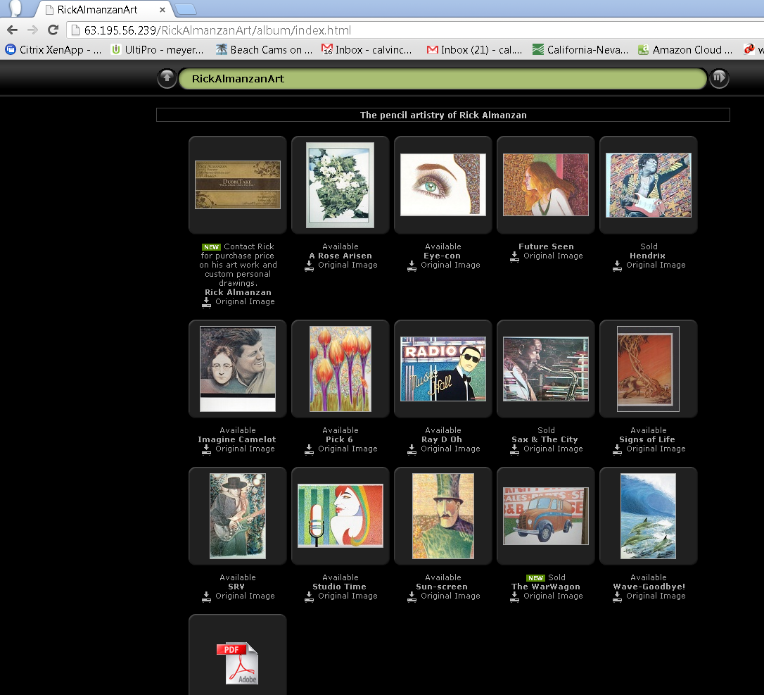

Rick art – names of images on BUBBA

With A = available and S = Sold
Img004 = Sun-screen -a(vailable)
Img027 = Studio Time –a
Img097 = SRV –a
Img102 = Pick 6 - a
Img120 = Imagine Camelot –a
Img121 = A Rose. Arisen. – a
Img122 = "Wave-Goodbye!" – a
Img549 = Eye-con – a
Img629 = Signs of Life – a
Img755 = Future Seen
Picture 620 = Sax & The City - s(old)
Picture 627 = Hendrix – s
Picture 645 = Ray D. Oh – a

